Take Action Against Distraction
NEW! 12,500 Schools Graded on Distraction Risk!
Every day in the U.S., nearly 60 kids under 19 are hit by cars while walking.

F A C T P O I N T
ACTION: Take Action Against Distraction
Danger
Students crossing busy streets while distracted by texting and talking on cellphones are in jeopardy.
Solution
Bring community together in an awareness campaign to discourage distracted walking.

Action
Run a “Take Action Against Distraction” campaign at your school

Here’s How:

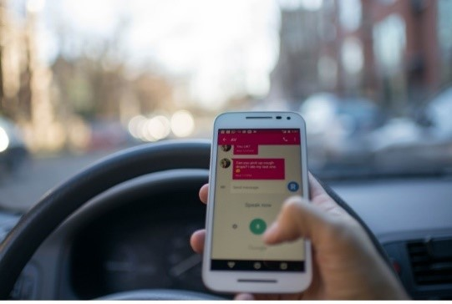
Sometimes passing laws is not the most direct route to make change. Grass roots action such as a community’s Action Against Distraction campaign can be important. For example, if traffic is routinely moving faster than a speed limit of 25 mph, ban together and hold concentrated, visible efforts to alert drivers of the speed limits. Six or eight of you holding colorful sign—“Slow Down, My Son Walks Here,” or “Didn’t You See the Speed Limit Sign?” can make a powerful statement. Don’t block traffic or get drivers mad at you. —make the statement we all have the right to do as part of our constitution. Similar tactics can make a powerful statement against distraction. Head Up, Phones Down is a simple, yet effective statement.
Advocacy is not always about passing laws. Creatively, stimulating grass roots activities can make a difference on discouraging distraction.
A D V O C A C Y T I P

Every day in the United States, nearly 60 kids under the age of 19 are hit by cars while walking.

Distracted walking is on the rise. In a study involving over 39,000 observations, Safe Kids Worldwide observed distracted walking in 1 in 4 high school students and 1 in 6 middle school students. These distracted teens were most often texting or wearing headphones.

Does Your School Have Signage with Safety Messaging about Distraction?
Feel free to download and print these signs that remind walkers and drivers to keep their heads up and phones down. You can put these in the grass around the school or hang them where students might be walking.
Preliminary Statistics Demonstrate How Important This Is
In March 2017, the Governor’s Highway Traffic Safety Association released data that pedestrian fatalities for the entire population (all ages) surged by 11 percent between 2015 and 2016, and that they make up 15 percent of all road fatalities, up from 11 percent in 2006. * This was the largest increase in pedestrian fatalities reported. In its report about the new data, GHSA suggested, “Another potential factor is a sharp rise in the use of smartphones to send and receive multimedia messages, a frequent source of mental and visual distraction for both walkers and drivers.” The report can help you get more local by providing state-by-state data. * There is not yet data specific to young pedestrians.
NEW!
“Good Tickets” Reward Good Behavior, Increase Awareness

Here’s an idea to help change behavior with an increase in awareness. In Saratoga County, New York, the county sheriff rewarded kids for wearing a bike helmet when bicycling, skateboarding or rollerblading with 5,000 “good tickets,” which doubled as a coupon for a free ice cream cone. Plus, kids who needed one received a free bike helmet. The Safe Summer campaign brought together State Senator James Tedisco (R), who sponsored it, and four ice cream stores, Stewart’s, Friendly’s, Ben & Jerry’s and a local one, Hayner’s. A law firm donated the free bike helmets. What about “good tickets” to reward kids who put down their phones when crossing the street?

Take Action
As leaders in your school and community you can help spread the word and take action to prevent injuries from distracted walking. We want student leaders to elevate this issue across your community to decrease and eventually eliminate distracted walking in and around your school and neighborhood.
Suggested Campaign Strategies
- Watch and share Moment of Silence video
- Watch and share Crossing the Street video featuring Patterson Park’s bucket band
- Watch and share Gary on the Street: Distracted Walking video
- Watch and share Southfield High School’s distracted walking video
- Distribute pedestrian safety and Moment of Silence posters to schools and community centers
- Share this interactive infographic that explores seven common ways kids get hit by cars while walking.
- Launch a social media campaign #HeadsUpPhonesDown
- Promote the distracted walking pledge
- Post distracted pedestrian tools on school website, closed circuit TV, community newsletters, etc.

Top Tips for Teens
- Put your device down, look, and make eye contact with drivers before crossing. Remember to watch out for cars that are turning or backing up.
- Always walk on sidewalks or paths and cross at street corners, using traffic signals and crosswalks.
- Be aware of others who may be distracted—and speak up when you see someone who is distracted.
- If you need to use a cell phone, stop on the sidewalk and find a safe area to talk. Look up and pay extra attention when using headphones and turn the volume off when crossing the street.

Top Tips for Parents
- Teach kids at an early age to put down their devices and then look left, right and left again when crossing the street.
- Set a good example by putting devices down when you are driving or walking around cars. If we put our devices down, our kids are more likely to do the same.
- When driving, be especially alert in residential neighborhoods and school zones and be on the lookout for bikers, walkers or runners who may be distracted or may step into the street unexpectedly.
Top Five Data Points on Distraction
- In 2015, teens ages 15 to 19 made up 26 percent of the under-20 population but about half of all pedestrian fatalities. *
- In 2015, 284 teens ages 12-19 were killed while walking; that’s more than five pedestrian deaths every week. *
- There’s been a 20-year downward trend in pedestrian fatalities involving kids, but over the past two years there has been a 13 percent increase in fatalities for pedestrians ages 12 to 19. *
- In 2015, one in every five children under the age of 14 who were killed in traffic crashes were pedestrians. *
- Pedestrian fatalities, as a share of all road deaths, all populations, grew from 11 percent in 2005 to 15 percent in 2015. *
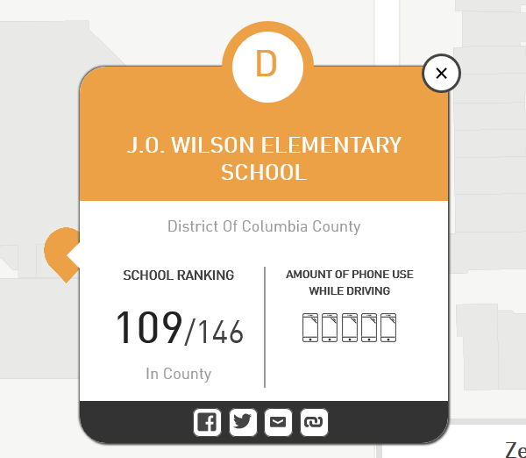
NEW!
Put Your School Zone to the Test
A new on-line tool was created by ZenDrive, a firm committed to using data and analytics. It can tell you how your school rates for distraction risk. The ZenDrive study found that 88 percent of trips it analyzed, a driver was using their smartphone and 1 in 3 drivers in school zones are engaged in unsafe behaviors. You can see if your school zone is one of 75,000 it tracked. For example, the elementary school closest to the home of this toolkit’s author, J.O. Wilson, received a “D.” The bad grade can help fuel your Take Action effort or an advocacy activity. If the distraction risk is high, so might follow other risks.

Watch the video and learn more about the Moment of Silence campaign

Five Strategies to Take Action on Distraction

- Fun: Make your campaign against distraction fun.
- Keep it Simple: Use the messages we suggest in the tool kits for the campaigns: “Take Action Against Distraction.” “Heads Up. Phones Down.”
- Infographics are a great way of getting out the facts and messages in a quick, visible and creative way. We’ve already created some for you. Use them!
- Use the facts: We know that every day in the United States, nearly 60 kids under the age of 19 are hit by cars while walking. Try to get that number for your state.
- Find volunteers! Many programs in schools (i.e. National Honor Society) require students to complete volunteer hours. Harness this and have students help raise awareness!

Let us know how it goes at advocacy@safekids.org
Or tweet your involvement using these tools.
Our community used @SKWAdvocate #safeschoolzone toolkit to
make our streets safer for our kids.

