School Bus Camera Campaign Toolkit
Every year, on average, 131 people die in school transportation tragedies.

F A C T P O I N T
ACTION: Stop School Bus Passers
Danger
Drivers are passing by stopped school buses at high speed, putting kids at serious risk.
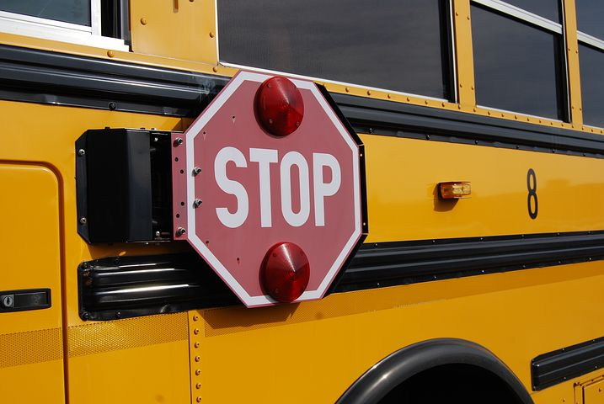
Solution
Placing cameras on the sides of school buses to catch and deter school bus passers.

Action
Push for law to allow placement of cameras on school buses.

Here’s How:
Model Letter Inviting People to Town Hall
Dear _____,

As a parent of a fifth grader at Greenleaf Elementary School, I am deeply concerned by the growing tendency for drivers to pass school buses at a high speed when the bus is stopped to pickup or drop-off young students. I join with other Greenleaf parents, police officers, teachers, school officials, school bus drivers, school neighbors and other interested citizens in inviting you to a town meeting. We’ll urge our State Senator and State Representative to introduce and support legislation that would allow our local government to place cameras on the side of school buses to identify and ticket school bus passers.

This happens with regularity even though the bus driver has lifted the bus lever clearly showing that the bus is stopped to load or unload students. This is a serious violation of the law.

There is a good reason why school bus passing is a serious traffic violation and why we need this measure as a deterrent to reckless drivers violating the law:

- Every year, an average 131 people die in school transportation tragedies. The National Highway Traffic Safety Administration reported in January 2017 that 1,313 people were killed in such crashes between 2006 and 2015. *
- The kids who attend Greenleaf are of the age which makes them vulnerable.* Of all school-age pedestrians killed in school transportation crashes, 33 percent were ages 5 to 7, and 34 percent were age 8 to 13. *
This is all good national data. It’s also important to gather data specific to your community. All politics is local.
A D V O C A C Y T I P
- It is estimated that there are 13 million school bus passing violations every year. *
- A 2014 survey of more than 97,000 school bus drivers in 29 states found that an estimated 76,000 vehicles illegally pass them on any given day. *
- In the 2013-2014 school year, there was a 15 percent decrease in violations on routes where cameras were installed. *

Moreover, because the violations can occur all along a bus route, this is a particularly difficult motor vehicle violation for our police to observe and enforce. We want to help make the job of police officers easier, more effective and safer.

What is the safest way for our children to get to school? According to the National Safety Council, a school bus is 13 times safer than riding in a car and 10 times safer than walking.* NHTSA says it is 50 times more likely for students to arrive safely at school when taking a bus rather than a car. * We must preserve this safe ride which more than 23 million kids take each school day. A school bus camera is a highly effective and low cost way to deter the dangerous practice of school bus passing.

Sincerely,
[your name]
Insert details on town meeting
Resources on School Bus Passing and Cameras
- Governing: Many States Using Cameras to Monitor School Buses *
- Stateline by Pew Charitable Trusts: 2015 article reviewing efforts to use school bus cameras *
- New York State citizens effort in favor of Stop Arm Cameras, including petition *
- Sample letter to legislators on school zone safety issue (school bus cameras) *
- Pluses and Minuses: It’s important to know the arguments against you! *

Best Practices on School Bus Cameras

Analysis on Alabama’s legislation, including discussion of fines. *

5 Lessons Learned: Using Cameras to Capture School Bus Stop Arm Violations (from corporate promotion website article) *
Potential Allies
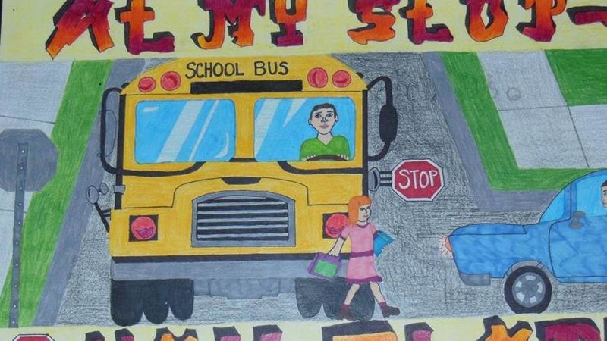
- National Association for Pupil Transportation *
- Your state Association for Pupil Transportation, for example, the New York Association for Pupil Transportation. *
  - NYAPT fact sheet on “Stop Arm” Camera bill *
  - NYAPT petition on change.org in favor of stop arm cameras. It was signed by 3,124 New York citizens. Illustration at left was used to promote the petition. *
Enacted Laws or Pending Laws

ENACTED

- Wyoming HB 5
- Maryland SB 679
- Alabama SB 215
- South Carolina S 718
- Connecticut § 14-279
- Georgia section 40-6-163
- Arkansas ACA § 6-19-125
- Illinois § 11-208(i)
- Mississippi SB 2472
- North Carolina § 20-217
- Rhode Island § 31-51-2
- South Carolina § 56-5-2770(D)(2)
- Virginia Section § 6.2-844
- Washington State section § 46.63.180
- West Virginia § 17C-12-7
PENDING
- New York S 518, A 321
- New Jersey S 211
- Arizona H1144
- Indiana H 1256
- Kansas H 2040
- Massachusetts H 2958 (2015 session)
- North Carolina S 55
- Tennessee SB 824 (Failed in committee)
- Maryland HB 1

Outline for Bill on School Bus Cameras
In many legislatures, rather than writing their own bills, legislative offices provide memos to lawyers who draft bills in the appropriate language. The following are bullet points for legislative drafting purposes.
- The goal is to create a deterrent to drivers passing school buses at high speed by placing cameras on the sides of buses and automatically issuing traffic tickets from the photograph/video.
- Emphasize that this bill only applies to school buses when a bus is stopped to pickup and drop-off pupils.
- If there is an excess of revenues from the automated enforcement, it would go into a dedicated fund to educate school children on safe pedestrian practices.
- Set a fine of $XXX, but do not assess penalty points.
- The school bus flashing light arm must be in working order. The photo(s) taken must show: that the school bus warning system is in operation; that the motor vehicle is passing the school bus; the license plate; make and model of the motor vehicle; and the date and time of the violation.
- The legislation will need to specify how a driver can contest the violation and address other procedural issues.
- Provide legislative intent, like this New York example: “Section 2. Legislative intent. In the state of New York, 2.5 million children ride school buses and public transportation to and from school each day. The legislature recognizes that the safe transportation of children to and from school is a shared responsibility of each school district and the driving public. It is the intent of this legislature to authorize school districts to utilize school bus safety camera technology, which will identify drivers who violate the law by passing a stopped school bus with its red flashing signal lamps illuminated and stop arm engaged.”

Six Ways to Get Your Way!
- Bus Drivers: Make sure the school bus drivers in the state support you. Promote it as a way to make their jobs easier and safer. If they don’t support you, you won’t get very far.
- Police Officers: You will also need police officers to support you. School bus passing is a hard law to enforce because it happens along a bus route.
- Research: Learn as much as you can about school bus use and bus passing in your state. How many kids use school buses every day? Have there been any incidents in the state? How many tickets for school bus passing in the last several years?
- Micro-research: Learn who important decision makers will be, usually the chairs and ranking member of the committee which will consider the bill. Learn about school bus safety in their districts in great detail.
- Keep it Simple: Maybe the simple message or Twitter hashtag is “Don’t Pass.”
- Get Personal with stories that show how this could improve safety!

Let us know how it goes at advocacy@safekids.org
Or tweet your involvement using these tools.
Our community used @SKWAdvocate #safeschoolzone toolkit to
make our streets safer for our kids.

