Bike Lane Campaign Toolkit
UPDATED! Good Tickets?
Bicyclists riding without bike lanes are nearly twice as likely to feel in danger as those who ride in bike lanes.
F A C T P O I N T
ACTION: Make Biking Safer with Protected Lanes
Danger
Bicyclists are at risk (and afraid) when riding on streets next to cars and trucks.

Solution
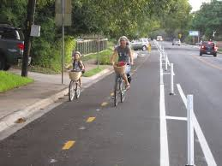
Make the bike trip to school safer with bike lanes and other safety improvements.

Action
Lobby City Council to fund a project to build a protected bike lane on the main street near schools, and other improvements.

Here’s How:

Sample Fact Sheet:
Why Greenleaf Middle School Students Need and Deserve a Protected Bike Lane

We want our children to start their lives in an active way. An active child is smarter and healthier. A favorite among kids is bike riding, but only 13 percent of children between age 5-14 were reported riding a bike to school in 2009 as compared to 48 percent in 1969.
We recommend that you conduct a survey of parents at your school and use the results to advocate in favor of the protected bike lane. Tips on school petitions are included below.

A D V O C A C Y T I P

According to a parent's survey, only XX percent of Greenleaf Middle School kids are riding bikes to school compared to XX percent four years ago even though XX percent live within three to four blocks of the school. Why? Parents tell us it's because they are worried about increased traffic in the roads near the school. There is a growing number of cars which are moving very fast.

We are advocating funding to build a protected bike lane along the road which most students take. Here's why:

Protected Bike Lanes Save Lives:
- A study of 10 U.S. cities, ranging from Minneapolis to car-centric Los Angeles, demonstrates that bike infrastructure improvements led to significant reductions in crashes and fatalities or severe injuries—specifically protected bike lanes.* *
- As Minneapolis grew its bike infrastructure between 2000-2015—including protected bike lanes—its bike crash rate per 100,000 trips in Minneapolis plunged 75 percent during that period and the rate of severe injuries and fatalities fell 79 percent.*
- Austin, Texas reported a 38 percent decrease in bicycle and pedestrian crashes after building bike lanes and installing other safety treatments. *
- In a before-and-after study done for Ingersoll Avenue in Des Moines, Iowa there was a 50 percent reduction in crashes after 6 months following a “road diet” that was put into place, including bike lanes going in both directions. *
Bicyclists Want Protected Lanes, and Feel Safer Riding on Them
In one of the first academic, U.S.-based studies of protected bike lanes, 62 percent of people surveyed said they were more likely to ride on a protected bike lane and 80 percent believed they are safer.*

An Effective Bike Safety Infrastructure Encourages More Kids to Bike

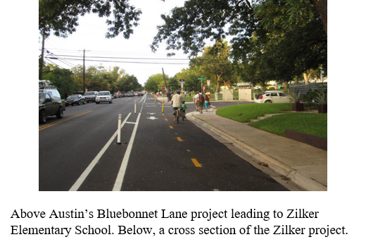
Communities which establish and grow their safe biking network see an increase in biking.* Austin, Texas -- in partnership with bike advocacy groups -- created a two-way, 1.5 mile bike lane on Bluebonnet Lane, which kids travel on to get to Zilker Elementary School. This led to a 46 percent increase in bike traffic after just one year.* The Rio Grande Avenue project in Austin led to a 126 percent increase in bike traffic.* In consistent studies, this has been the overwhelming experience when Safe Routes to School program additions are made.* Safe Routes projects have been reported to increase bicycling by 24 percent.* Another study concluded that engineering improvements led to an 18 percent increase in biking and walking.* In a range of cities, large and small, bike traffic grew significantly: on L Street, Washington DC (65 percent), on Dearborn Avenue, Chicago, IL (171 percent) and on Multnomah Street, Portland, OR (68 percent).*

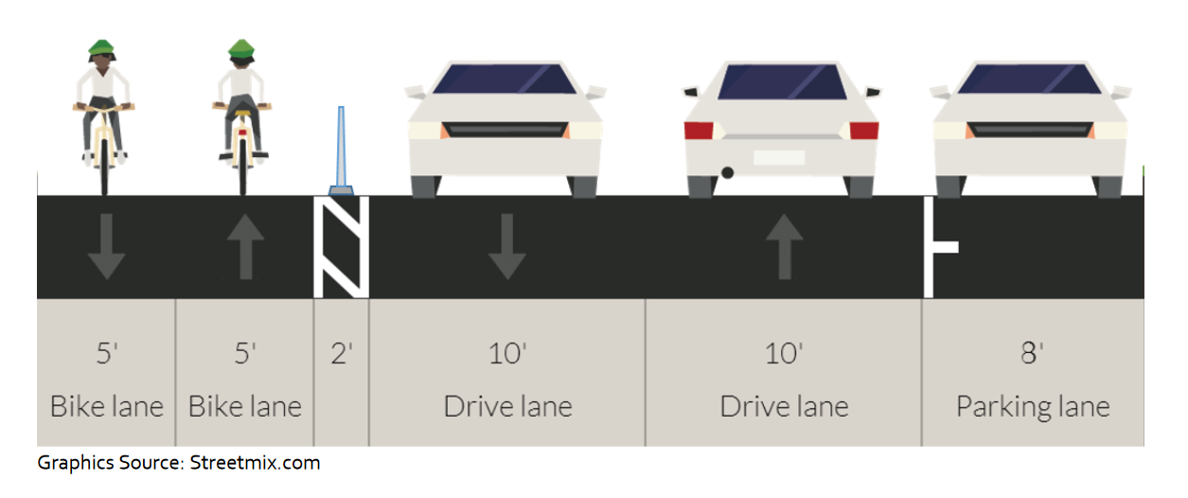
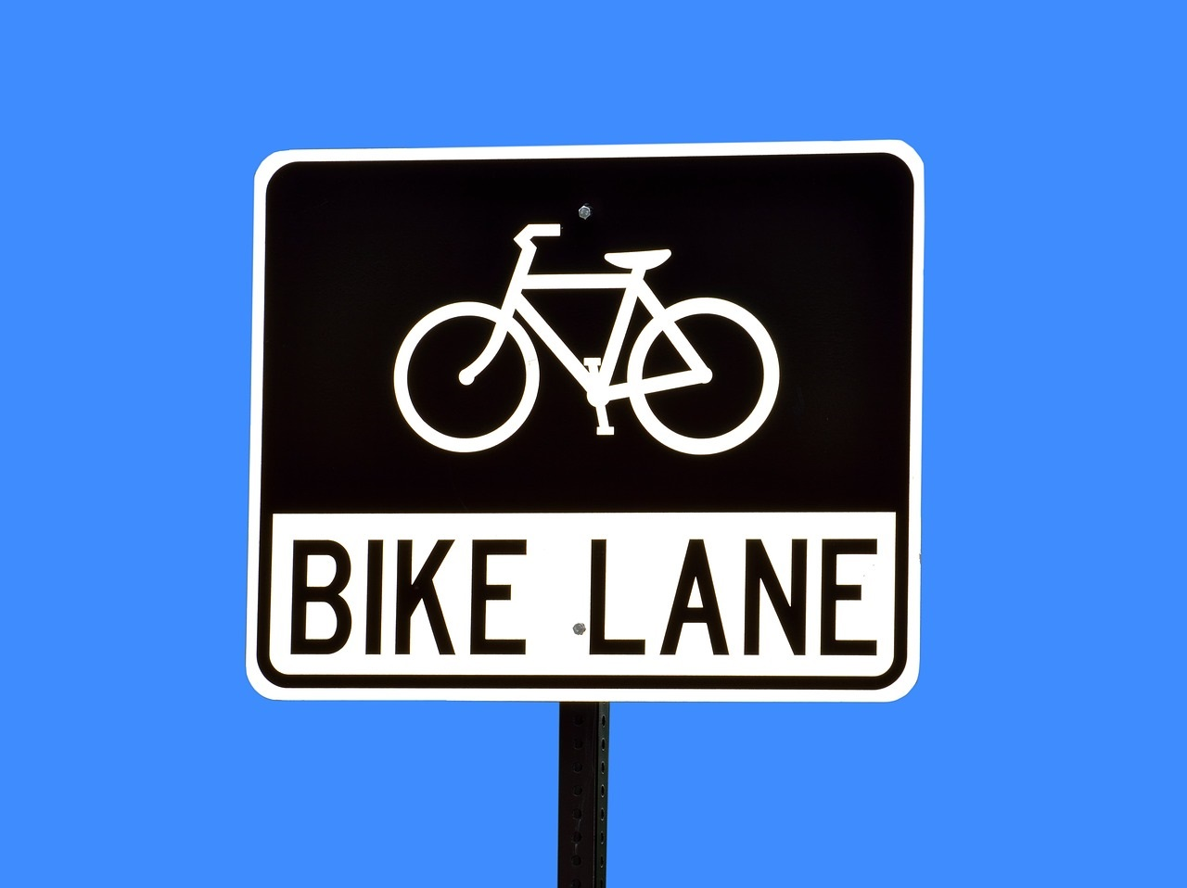
The More Kids Bike, the Healthier They Are

Children who regularly ride a bike are less likely to become overweight,* more likely to improve cardiorespiratory health,* and breathe less vehicle carbon than those regularly riding a school bus.*

Kids Who Are More Physically Active Grow Smarter Brains

A student who exercises regularly develops a more effective brain* which leads to positive mental health outcomes, according to an article in the Journal of the American Medical Association Pediatrics.* They also tend to watch less television* and are less likely to pick up the smoking habit.*
“Good Tickets” Reward Good Behavior, Increase Awareness

Here’s an idea to enhance wheeled sports safety by encouraging use of bike helmets. In Saratoga County, New York, the county sheriff rewarded kids for wearing a bike helmet when bicycling, skateboarding or rollerblading with 5,000 “good tickets,” which doubled as a coupon for a free ice cream cone. Plus, kids who needed one received a free bike helmet. The Safe Summer campaign brought together State Senator James Tedisco (R), who sponsored it, and four ice cream stores, Stewart’s, Friendly’s, Ben & Jerry’s and a local one, Hayner’s. A law firm donated the free bike helmets. This could be a smart strategy to reel in a political leader.

Testimonials
“[My son is] scared to ride on many streets. My feeling is that a physical separation from the traffic is far more comfortable.” - Amy Brugh, a resident of Northrop, MN, who feels much greater confidence when riding with her 10-year-old son on their tandem bicycle. *
“Bicycle infrastructure with physical separation from motor vehicles is especially important on high-speed, high-volume arterials with large vehicles such as trucks and buses. . . . [T]he safest kind of facility, by far, were cycle tracks, which are on-street bicycle lanes that are physically separated from motor vehicles by raised curbs, bollards, or concrete barriers.” - John Pucher, PhD, and Ralph Buehler, PhD, writing for the American Public Health Association *
“The protected bike lane can make a huge difference, in particular for the average person who maybe doesn’t ride every day…. It will make them feel like ‘I can get on a bike too,’ or ‘I wouldn’t mind if my child rode a bike to school.’” - Gabe Klein, former Chief Transportation Official of Chicago, Illinois *
Resources Bike Lanes and Safety
- Federal Highway Administration on Bicycle and Pedestrian Transportation *
- Pedestrian and Bicycle Information Center
- Protected Bike Lane Statistics *
- Separated Bike Lane Planning and Design Guide *
- Safe Routes to School: On-Street Bicycle Facilities *
- Safe Routes to School Event Guide *

Five Top Data Points
- Bicyclists riding without bike paths or lanes are nearly twice as likely to feel at risk (mostly by motorists) compared to bicyclists with paths or lanes *
- Bike lanes cut injury risk by 50 percent, dedicated bike lanes cut it by 90 percent. *
- Between 2000 and 2012, as bike infrastructure was being developed at a faster pace, there was a 65 percent increase in the number of people biking. *
- Increased bicycling leads to health benefits, like less obesity and less risk of heart disease, as well as environmental benefits such as reduced noise pollution and air pollution. *
- Bike-specific infrastructure along major streets has been found to lower the risk of injury for bicyclists. *
Sample Survey of Parents
- Safe Routes to School in English *
- Safe Routes to School in Spanish *

Six Ways to Get Your Way!
- Build Coalitions with Out-of-the-Box Partners: Look at getting the message out to places bicyclists frequent: bike shops, coffee shops with lots of bikes parked outside and bikeshare docks. In Portland, for example, small businesses joined the lobbying for protected bike lanes who “understand the power of safe.” * Also consider tourism interests in your city, because bike-tourism is very competitive.
- Not Just Kids: Remember that this is one effort that can improve the lives of everyone who rides a bike, not just children. Recruit them.
- Editorials and Letters to the Editor: Visit your town’s newspaper editorial staff to enlist their support. Run a campaign of kids writing letters to the editor in favor of bike lanes.
- Social Media: Spread your message on Twitter, Facebook and Instagram.
- Research: Identify city council members and other city leaders who bike, and get their support. Council members who have children might also be good targets for support.
- Lights! Camera! Action! Create short videos. Use humor. Show bicyclists relaxed and joyful on a protected bike lane, compared to a rider in thick and fast moving traffic.

Let us know how it goes at advocacy@safekids.org
Or tweet your involvement using these tools.
Our community used @SKWAdvocate #safeschoolzone toolkit to
make our streets safer for our kids.

Photo: Illustration courtesy of Christopher M. Monsere, Ph.D., P.E., Portland State University, 04.21.2017, photo courtesy City of Austin, TX
Bike lane sign, pixabay.com, https://pixabay.com/en/bike-land-sign-signage-road-sign-1738277/

