School Drop-Off/Pickup Campaign Plan
New! School Zone Distraction Law *
In one city, over four years, nearly 1,700 children ages 5 to 18 were hit by cars within a block of a school.

F A C T P O I N T
ACTION: Make Drop-Off/Pickup Safe
Danger
Children in jeopardy because the drop-off pickup zone is chaotic and hazardous.
Solution
Develop a sensible drop-off/pickup plan for the school, and enforce it.
Action
Push school board to adopt a drop-off/pickup plan, and provide the resources to make it work.
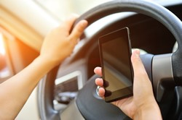
Here’s How:
Sample Letter to School Board
We are joining together as parents of Greenleaf Elementary School students because we are deeply concerned about the chaotic nature of the student drop-off/pickup area at the school, and fear that this is a tragedy waiting to happen.

Together with the Greenleaf Elementary Parent Teacher Association, we seek a meeting with the school board and safety representatives of <name of school board jurisdiction> to discuss the hazards we have observed and the need for a specific drop-off/pickup policy, as well as school supervision of the process. Our plan should also address how school buses unload and load students. We have identified examples of successful drop-off/pickup plans. We are committed to working with you on the implementation and supervision of the plan.
If there’s been an incident, share it in your letter. See the story below about a girl who was hit in a designated drop-off/pickup area at a school in Rhode Island.
A D V O C A C Y T I P

We are greatly concerned about the incident that occurred recently which led to the hospitalization of a Greenleaf Elementary student. According to Greenleaf police, this occurred when a driver made a U-turn into a driveway one block away from the school. Fortunately, the student was not seriously injured and was released that day after being seen by emergency room physicians. We need to take action before a more serious incident takes place.

We know the dangers facing the students at Greenleaf Elementary are not unique. In October 2016, Safe Kids Worldwide (Safe Kids) issued a research report, “Alarming Dangers in School Zones.” * The report, based on more than 39,000 observations of kids crossing streets and 56,000 observations of drivers driving in school zones, identified that unsafe drop-off/pickup behavior was seen in nearly 1 in 3 drivers. Safe Kids found that while a large percent of participating schools had policies on the books, the policies were not being enforced.

We believe strengthening and enforcing our school drop-off/pickup up plan will save lives and is cost effective, especially considering the costs that are incurred by taxpayers when crashes take place in school zones.

We recognize that this needs to be a community effort and we are not counting on the school to do the job alone. Teachers, parents and the school district need to work on this together to make the area safer. We know that everyone at Greenleaf works very hard. Therefore, we are committed to working with you on this effort every step of the way, including volunteer parents who will help oversee the drop-off and pickup of our children.

We thank you for your receptiveness to our ideas to make Greenleaf safer for our kids and the entire neighborhood. We’ll be in touch with you soon to meet about this important effort. Let’s make Greenleaf Elementary safe for all our children.

Call to Action Message

Greenleaf parents, pupils, teachers, administrators, neighbors, alumni and concerned citizens:

Please join us in asking for action to make the school zone around Greenleaf safer. The drop-off and pickup area at Greenleaf Elementary School is dangerous and chaotic. We need to ensure our children can get to and from school each day safely. According to research, nearly 1 in 3 drivers display unsafe drop-off/pickup up behaviors such as double parking or stopping in the middle of a crosswalk while dropping off students. We have observed these behaviors in the drop-off/pickup area at Greenleaf Elementary. Please join the Greenleaf Elementary School Parent Teacher Association in writing to the school board urging them to work with us to strengthen and enforce our school drop-off/pickup policies and help keep our kids safe.
Online Resources: Best Practices
Here are some model drop-off/pickup plans as a starting place.
A D V O C A C Y T I P
Safe Routes to School Best Practices on drop-off/pickup Plans *
Seattle Best Practices for drop-off/pickup Plans *

Online Resources: Model Plans and Stories About Drop-Off and Pickup Plans

Safe Kids Worldwide: Sample School drop-off/pickup Policy blog: “5 Ways to Make Your Child’s School Zone Safer” *

City of Phoenix Model drop-off/pickup Plan *

McDonald International School drop-off/pickup Procedures, Seattle, WA *

Hamilton Elementary School, Pasadena, CA (at right) *

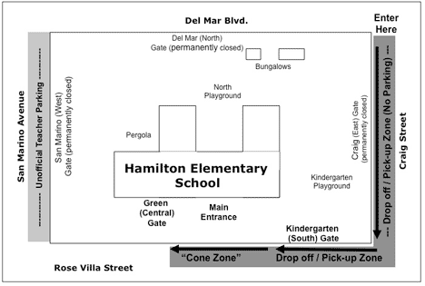
New drop-off/pickup Plan Ready for New Spring Valley School, La Salle, IL, News Tribune *
Negative Events and News Stories Can Influence Change

- Trustees like Windsor Elementary Expansion Plan, Except for Traffic, Chicago, Daily Herald *
- Sixth Grader Struck By Car In Providence, RI Causes School to Reevaluate Drop-Off, Pickup*
Legislation You Can Consider
While we focus in this section on action not involving a proposed law, some states are looking at legal remedies to address these issues. Here are some examples:

- Texas HB 520 to prohibit texting when driving in a school zone or when a minor is in the motor vehicle. *
- Vermont H 8 to raise penalties for distracted driving with electronic devices in school zones. *
- Kansas S 144 to prohibit use of wireless communications equipment in a school/work zone. *
New! Tennessee Passes Law on Cell Phone Use in School Zones

Distraction from the use of cell phones is a factor which makes drop-off, pickup zones more dangerous. Should there be a law? Tennessee legislators think so. It passed HB 868 * making it illegal to talk on a hand-held cell phone while driving in a school zone, adding to an existing law which makes it illegal to text while driving in a school zone. There’s an exception for a driver 18 and older using a cell phone with a hand free feature. The law was effective on January 1, 2018. * You might consider advocating for this bill, and can use the strategies laid out in the campaign plan for reducing the speed limit.

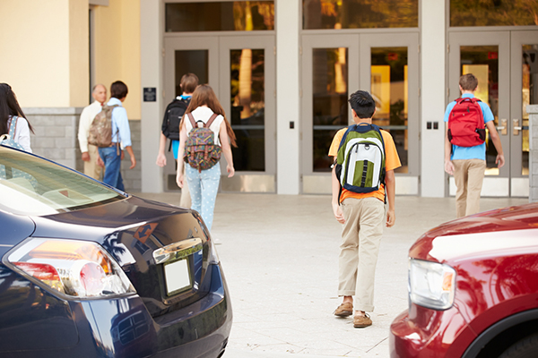
Six Data Points

- A recent Safe Kids Worldwide study with more than 56,000 observations of drivers in school zones found that approximately 1 in 10 drivers were distracted by mobile devices while arriving or departing from the school and nearly 1 in 3 displayed other unsafe behaviors, such as double parking or stopping in the middle of a crosswalk while dropping off students.
- The same study found that nearly 9 out of 10 middle schools and 8 out of 10 high schools had some sort of school policy related to drop-off/pickup zones. However, 4 out of 10 middle schools and 6 out of 10 high schools did not enforce the existing policy. *
- The same study found the mere presence of a policy did not affect behavior. However, drivers at schools where a policy is in place and enforced were significantly less likely to engage in unsafe behavior. This suggests that having a policy is not enough, and schools need to look at ways to enforce them. *
- While there’s been an historic trend over 20 years of declining fatality rates involving pedestrians, there has been a 13 percent increase in the fatality rate for pedestrians ages 12 to 19. *
- Each school year, nearly 54 million school-age children walk or bike to school or otherwise pass through the school zone after exiting a caregiver's car or the school bus. *
- A study of school zones in Chicago reported that between 2007 and 2011, nearly 1,700 children ages 5 to 18 were struck by cars within a block of their school. *

Four Ways to Get Your Way!
- Hold a Public Meeting to compare ideas, engage in a discussion with other interested individuals and obtain buy-in from stakeholders.
- Follow up with those who have helped you in your campaign--to keep them engaged on this effort, and for the future.
- Attend school functions to gauge interest and recruit new supporters.
- Work with Local Law Enforcement to see if they can help brainstorm an effective drop-off and pickup plan.

Let us know how it goes at advocacy@safekids.org
Or tweet your involvement using these tools.
Our community used @SKWAdvocate #safeschoolzone toolkit to
make our streets safer for our kids.

Courtesy Pasadena Unified School District, https://www.pusd.us/domain/1541

