Traffic Calming Campaign Toolkit
Installing lighted crossing signs have a 78 percent success rate in encouraging cars to yield to pedestrians.

F A C T P O I N T
ACTION: “Calm Traffic,” Save Lives
Danger
Children on foot are at risk when school crosswalks don’t guide them with signs, clear crosswalks, and other protective measures.

Solution
Make school crosswalks safer with “traffic calming” measures like flashing signs and easy-to-see crosswalks.
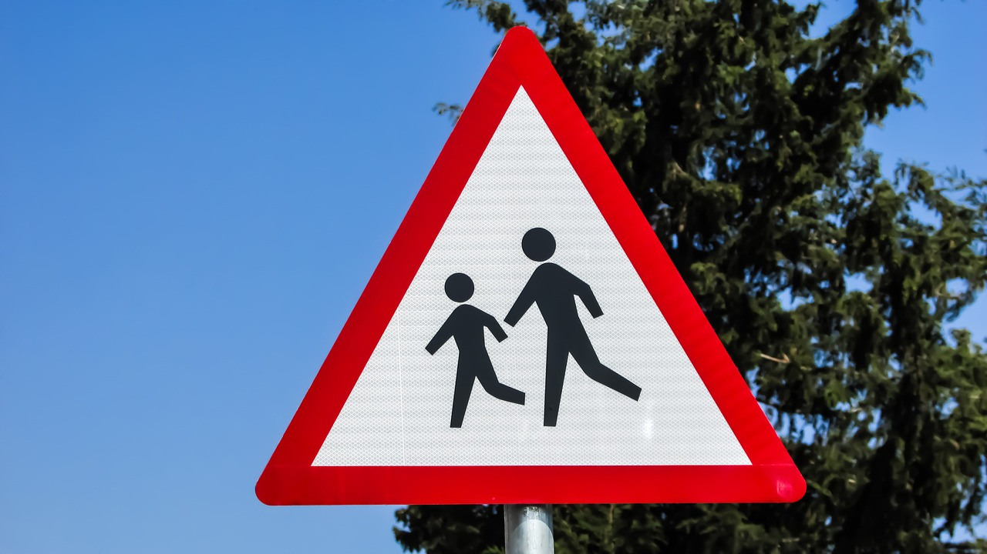
Action
Lobby City to plan and fund for protective measures, which can be both less costly and effective.

Here’s How:

Model letter
Dear Mayor Gosling: (or City Council, School Board, etc.)

As a parent of a 4th and 6th grader at Greenleaf Elementary School, I am deeply concerned about the severe risk which exists at the intersection of Greenleaf Avenue and Yellow Street. The situation makes it extremely difficult for my children, ages 9 to 12, to cross the street. I have observed the following at the intersection of Greenleaf and Yellow:

- There are no warning signs telling a driver that they are entering a school zone.
We recommend you conduct a road safety audit * of issues in your school zone, and provide them in the letter. This can be a group effort as an early start towards consensus.
A D V O C A C Y T I P
- The crosswalks, many years old, are hardly visible, especially to a driver.
- While the speed limit is 35 mph, I routinely see drivers going faster than 35, which I can measure by the speed I am traveling.
- Greenleaf does not have a crossing guard.
- Students commonly walk across the street mid-block and exhibit other risky behavior.
I know that there are a number of different measures which can be used to make a school zone crosswalk safer. Recognizing that our City has budget constraints, parents and neighbors near Greenleaf have reached a consensus to urge the City to make two changes: 1) invest in “School Zone” flashing signs at both ends of Greenleaf Avenue, and a “flashing beacon” so drivers are more aware they are entering a school zone; and 2) repaint or reapply the crosswalk markings so they are highly visible, based on traffic control standards. *

These measures work. A Columbia University study evaluating the Safe Routes to School program said that communities which added crosswalks and other safety improvements saw traffic injuries reduced by one third, while areas with no safety modifications saw no progress. In addition, studies have shown that children this young do not develop the cognitive ability to gauge if it’s safe to cross the street, so they need street improvements like these to help them cross safely. * *

We hope you will consider these practical safety measures. The parents at Greenleaf would appreciate the opportunity to speak to you or city officials to discuss the danger to our children and work together to protect our youngest citizens.

Sincerely,

Your name here
Call to Action Message to Community
Greenleaf parents, pupils, teachers, administrators, neighbors, alumni and concerned citizens:

Please consider sending a letter to the Mayor, members of the City Council and the School Board President in favor of a wise investment in measures to make children safer in the crosswalk(s) at Greenleaf Elementary.

The Danger:
We have seen the following at this intersection: drivers go too fast, even faster than the posted 35 mph speed limit. At Greenleaf Avenue and Yellow Road, there are no signs telling drivers they are entering a school zone. The crosswalk markings are old and difficult for a driver to see. The intersection is chaotic and confusing even for an adult, but especially so for 6 to 12 years old. Science tells us that children this young do not develop the cognitive ability to gauge when it’s safe or not safe to cross the street. We need ways to calm traffic and caution drivers as they enter the school zone.

The Solution:
We reached a consensus in favor of flashing “school zone” alert signs, a “flashing beacon” and, because the crosswalk’s markings are “worn-out,” to repaint or reapply high-visibility crosswalk markings.
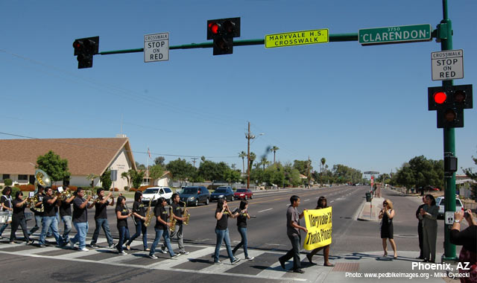
The Action:
Together, we need to make change. Please send our public officials a letter or email. Their contact information is below.

Sincerely,

Provide contact information for the public officials you choose to target with this activity. Most city and state governments have websites to tell you how to reach their public officials.
Online Resources: Traffic Calming Sites

- U.S. DoT Traffic Calming ePrimer *
- AARP traffic Calming: A Livability Fact Sheet *
- Project for Public Places: Traffic Calming 101*
- Federal Highway Administration Traffic Calming *
- Institute of Transportation Engineers Review of Traffic Calming Measures *

Online Resources: Traffic Calming Programs; City-Specific
- Overland Park, Kansas – formed a traffic calming task force *
- Turlock, California – erected speed bumps and median islands *
- Albany, New York – installed “speed tables” (longer versions of speed bumps) in trouble areas *
- Richmond, Virginia – installed temporary measures to make sure they’ll work in that neighborhood *
- St. Petersburg, FL – experienced at least a 70 percent success rate (yielding to pedestrians) with flashing beacon systems. *
Online Resources: Law Enforcement Strategies
- U.S. DoT Guidelines for High-Visibility Enforcement *
- The Police Chief: Traffic Safety through High-Visibility Enforcement *
- Law Enforcement Executive’s Guide to High-Visibility Enforcement *
- CBS story on school zone traffic (and not a positive one!) *
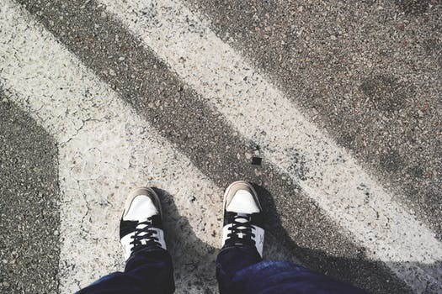
Top Seven Data Points

- NEW! According to the Global Street Design Guide, supported by the Bloomberg Initiatives, “Children are less capable of judging speed than adults, placing the responsibility of providing safe movement options on designers and drivers.” *
- When a car is going 35 mph and hits a pedestrian, the risk of death is 30 percent and of significant injury is 64 percent. However, a speed limit of 15 mph reduces the risk of death to 5 percent and 10 percent for serious injury. *
- With visible crosswalks and other safety changes in NYC neighborhoods, they experienced a reduction in traffic injuries by 1/3. Areas with no safety modifications experienced no progress in Columbia University study. *
- The Federal Highway Administration has found that crashes in which a car hits a pedestrian walking on the side of the road consistently falls by more than 50 percent when sidewalks are installed. *
- Installing speed bumps can reduce average speed by roughly 4 to 7 mph and traffic volume by as much as 130 vehicles per day. *
- According to a Minnesota analysis, “pedestrian hybrid beacons,” also known as high-intensity activated crosswalks (HAWKs) have a success rate of at least 78 percent in causing motor vehicles to yield to pedestrians. Such systems can range from $15,000 to $80,000*
- Traffic calming increases drivers’ abilities to avoid accidents, decreases severity of accidents and produces economic benefits as well. *

Five Ways to Get Your Way!

Cost out the traffic calming measures. You and others will be surprised at how little some of the improvements can cost. According to the FHWA, a Rectangular Rapid Flash Beacon, can cost $10,000-$15,000.
- Tell quick stories about how a traffic calming measure saved lives in another city or town similar to yours. (see online resources)
- Let Neighbors be Neighborly: make sure you have strong support from neighbors of the school who don’t have kids. Get their buy-in early. Include and update them along the way.
- Law Enforcement Buy-in is critical too. The police station might be your first stop.
- Anticipate arguments against your goals. For example, an innocuous measure like timing traffic lights to give pedestrians a head start can lead to traffic jams. Develop your talking points to respond.

Let us know how it goes at advocacy@safekids.org
Or tweet your involvement using these tools.
Our community used @SKWAdvocate #safeschoolzone toolkit to
make our streets safer for our kids.

Crossing street, pexels.com, https://www.pexels.com/search/crosswalk/

