ACTION: Stop Speeding in School Zone
Sensible Speed Limit Tool Kit
UPDATED! NTSB Reports Speeding is Major Factor in Fatal Crashes
Lowering speed from 30 mph to 20 mph can reduce fatality rates by up to 40 percent.

F A C T P O I N T
Danger
Drivers are moving too fast in school zones and the speed limit is too high, putting children in danger.
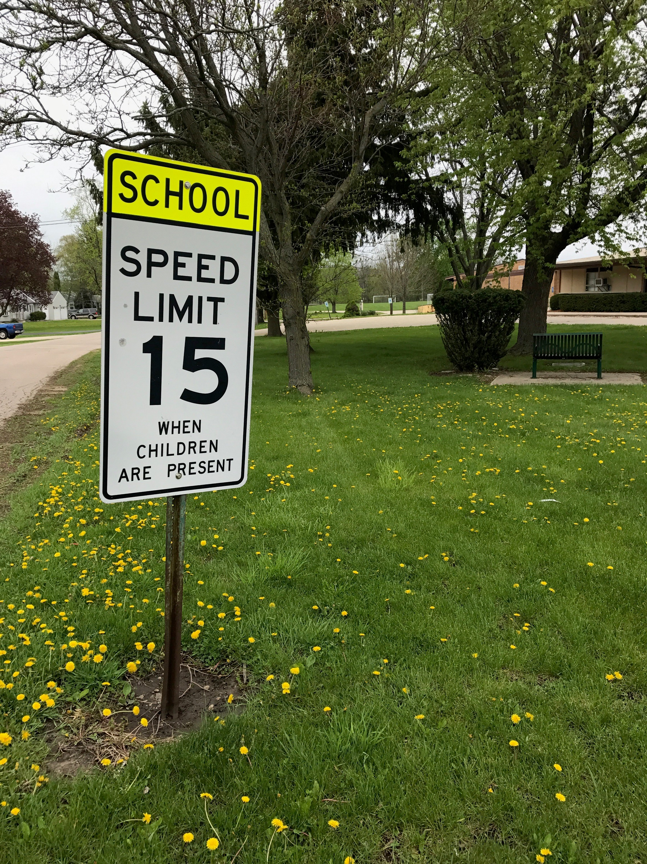
Solution
Pass a law to lower school zone speed limits to no more than 20 mph.
Action
Run a petition campaign to pass a law enabling your local governments to lower school zone speed limits to no more than 20 mph.
Here’s How
Model Petition
Slow Down Speeding Cars in Our School Zones

We Petition Our State Legislature to Take Steps to Reduce Speeding on the Roads Around Greenleaf Elementary and Schools Throughout Our State. I am a student, parent, teacher, neighbor, friend, former student or interested citizen and I care deeply about Greenleaf Elementary School in Greenleaf Borough. I am joining with others to take action to reduce speeding traffic in the zone around the school. The 35 mph speed limit in the school zone around Greenleaf Elementary already allows drivers to go too fast, and we have observed that traffic is going even faster than the speed limit.
I urge the state legislature to pass a bill allowing our local government to reduce the speed limit to no more than 20 mph at the beginning and end of the school day, and possibly 15 mph. Our children range from 5 to 11 years old and don't understand the dangers of speeding traffic. Science tells us that the brains of kids this young do not develop the cognitive ability to gauge when it’s safe or not safe to cross the street.

Our proposal is supported by evidence. Speed can determine the difference between life and death.
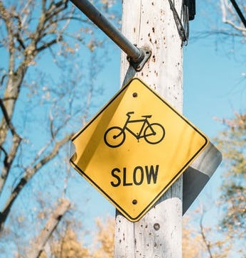
According to research by the AAA Foundation, when a car is going 35 mph and hits a pedestrian, the risk of death is 30 percent and of significant injury is 64 percent. However, a speed limit of 15 mph reduces the risk of death to 5 percent and 10 percent for serious injury. In a report issued by Safe Kids Worldwide—which was based on observations at about 80 schools in 15 states--low speed limits (20 mph or less) were observed in only about 4 out of 10 school zones.

By lowering the speed limit, and then enforcing it, roads in the Greenleaf school zone will calm down so cars have time to stop and children can walk to school safely.

In addition, we applaud the work of our police officers in making the Greenleaf community safer. With this petition, we are asking our police to provide a greater presence in the school zone, especially at the beginning and end of the school day.
Call to Action Message
Greenleaf parents, pupils, teachers, administrators, neighbors, alumni and concerned citizens. Please sign our petition asking for action to make the school zone around Greenleaf safer. Drivers go too fast, even faster than the posted 35 mph speed limit. According to research, when a car is going 35 mph and hits a pedestrian, the risk of death is 30 percent and of significant injury is 64 percent. But if reduced to 15 mph the risk of death drops to 5 percent and 10 percent for serious injury. Speeding cars routinely pass school buses picking up or dropping off kids. At Greenleaf Avenue and Yellow Road, there are no signs, crosswalk markings or other ways to calm traffic and allow children ages 5 to 11 to walk across the street safely.
We suggest you be as specific about the rate and level of speeding in you school zone. The police might be able to help you.
A D V O C A C Y T I P

Together we need to make change, and we cannot place all of the responsibility on the school. Please sign our petition in favor of state legislation to allow lower speed limits in school zones.

Online Resources: Free Petition Sites
- Care2 *
- Causes *
- Petition Buzz *
- Act.ly (twitter petition) *
- Action Network *
- WordPress: SpeakOut! *
- Change.org *
- Petition effort in favor of school bus cameras *

Online Resources: Expertise on Petitions

- 9 Tips to Run a Successful Petition Campaign (based on change.org)*
- How to Write a Winning Petition by change.org Leader*
- Conducting a Petition Drive by Community Toolbox*
- How to Organize an Effective Petition Campaign by American Association of University Women*
- 5+ Petition Templates on template.net*
- How to Write a Petition (international site, gopetition.com)*
- Petition Examples from gopetition.org*
- Sample letter to legislators on school zone safety issue (school bus cameras)*

Five Top Data Points to Cite in Your Position
- The National Transportation Safety Board reported in July 2017 that speeding is a factor in fatal crashes at about the same frequency as drunk driving. *
- When a car is going 35 mph and hits a pedestrian, the risk of death is 30 percent and of significant injury is 64 percent. However, a speed limit of 15 mph reduces the risk of death to 5 percent and 10 percent for serious injury. *
- Crashes involving a pedestrian on the side of the road are consistently reduced by 50 percent when sidewalks are built. *
- In 20 mph speed zones the number of traffic accidents decreased by 60 percent, and child pedestrian fatalities and child cyclist fatalities were reduced by 67 percent.*
- Results from international studies suggest that for every 1 mph increase in speed, the number of crashes will rise by 5 percent. *

Six Ways to Get Your Way!

- Reach: Be creative in expanding your vision of who can sign your petition. Would the nearby 7/11 or gas station put your petition at the cash register? Can you get kids to promote the petition at shopping malls?
- Speed Test: Ask the police department to conduct a speeding study on roads near the school.
- One or Two Words can embrace your effort. The easiest might be “SLOW DOWN” as a headline for the petition, a twitter hashtag #slowdown
- Ready for Your Close-up? Use cell phones to make 30 or 60 second videos to spread your message online. Consider filming a diverse group of kids from the school saying “Slow down.” Other ideas include filming cars speeding by the intersection or filming police officers talking about the challenge to law enforcement. This need not be Hollywood quality, and you can take very nice videos with cell phones. (For any of the film projects, make sure to inform the school and to get releases from parents.)
- Don’t be Scary: The issue is scary—because speed kills--but don’t repel people with scary images or videos.
- Goal: Make a goal of how many signatures you need to get the point across, and make the goal challenging and achievable.

Let us know how it goes at advocacy@safekids.org
Or tweet your involvement using these tools.
Our community used @SKWAdvocate #safeschoolzone toolkit to
make our streets safer for our kids.

Photo: Slow down sign, pexels.com, https://www.pexels.com/photo/autumn-autumn-leaves-branches-danger-305236/
Photo: Sign up, pexels, https://www.pexels.com/photo/business-signing-writing-writer-24193/

